Considering the Key Aspects of EASA Part 147 Training Needs Analysis (TNA)

What is a Training Needs Analysis (TNA) ?

It is the main driver to determine the duration of the theoretical element of the type training, regardless of whether it is above or below the minimum duration contained in EASA Part 147 Appendix III.

TNA Background

Introduced in point 3.1(d) of Appendix III and corresponding AMC.

Applicable to the theoretical element of courses either carried out by Part-147 organisations or directly approved by the competent authority.

Required in order to justify the duration of the theoretical element of the type training.

Note - In Opinion 05/2009 the Agency proposed not to require a TNA for courses already approved which had a duration equal or above the minimum duration established in the new Appendix III. However, the final Regulation EU1149/2011 required the TNA for all courses, including those courses approved before 01 August 2012, for which the content had to be adapted to the new rule and the TNA had to be produced by 01 August 2013.

The purpose of the table of minimum duration is to provide a reference both to the organisation and the competent authority of what to expect as an average for the corresponding category of aircraft. Indicates also to the authority the level of detail of the scrutiny to be performed.

For example:

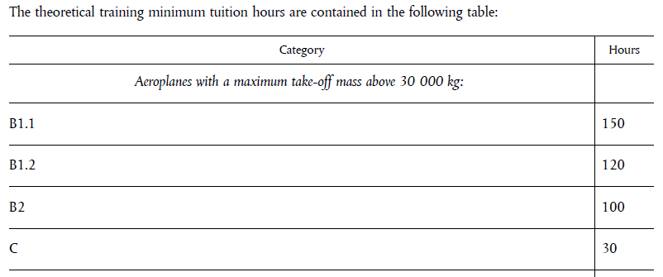

The average duration for a course of an aircraft above 30000Kg MTOM is 150 hours. (Note this is a minimum)

A proposal for a course on an Airbus 380 or a Boeing 747 of 150 hours may require a close look to the TNA, because most likely the course may need a longer duration.

A proposal for a course on a Learjet 45 of 120 hours, even when it is below the minimum duration (average for the category) may be easily justified by the TNA and may not need such an in-depth investigation.

Aeroplanes with a maximum take-off mass of 5700 kg and below1
B1.1 | 80
B1.2 | 60
B2 | 60
C | 15

Justification of course duration:

Training courses carried out in a maintenance training organisation approved in accordance with Annex IV (Part-147) and courses directly approved by the competent authority shall justify their hour duration and the coverage of the full syllabus by a training needs analysis based on:
the design of the aircraft type, its maintenance needs and the types of operation,
detailed analysis of applicable chapters — see contents table in point 3.1(e) below,
detailed competency analysis showing that the objectives as stated in point 3.1(a) above are fully met.

Where the training needs analysis shows that more hours are needed, course lengths shall be longer than the minimum specified in the table.

Similarly, tuition hours of differences courses or other training course combinations (such as combined B1/B2 courses), and in cases of theoretical type training courses below the figures given in point 3.1(c) above, these shall be justified to the competent authority by the training needs analysis as described above.

The content and duration deriving from the TNA may be supported by an analysis from the TC holder.

Key aspects of the TNA:

It takes into account (among other aspects):

The particular aircraft type, applicable systems, maintenance needs and operational experience.

The corresponding Instructions for Continued Airworthiness and other maintenance documentation available.

The learning objectives (what is expected to be achieved by the student taking into account the content and level of training defined for each licence category in Appendix III).

Appropriate coverage of typical tasks (removal/installation, testing, servicing, inspection, troubleshooting, etc).

Sequence of learning.

Instructional methods.

Documentation and resources available to the student.

The maximum number of training hours per day (recommended 6 full hours excluding breaks, examinations, aircraft visits, etc).

Minimum participation time from the student (not less than 90%)

When developing the TNA the following should be considered:

(a) The TNA should include an analysis identifying all the areas and elements where there is
a need for training as well as the associated learning objectives, considering the design
philosophy of the aircraft type, the operational environment, the type of operations and
the operational experience. This analysis should be written in a manner which provides a
reasonable understanding of which areas and elements constitute the course in order to
meet the learning objectives.

(b) As a minimum, the Training Need Analysis (TNA) should take into account all the
applicable elements contained in paragraph 3.1 of Part-66 Appendix III and associated
AMCs.

(c) The TNA should set-up the course content considering the Appendix III objectives for each level of training and the prescribed topics in the theoretical element table contained in
paragraph 3.1 of Part-66 Appendix III.

(d) For each chapter described in the theoretical element table contained in paragraph 3.1
of Part-66 Appendix III, the corresponding training time should be recorded.

(e) Typical documents to be used in order to identify the areas and elements where there is
a need for training typically include, among others, the Aircraft Maintenance Manual,
MRB report, CMRs, airworthiness limitations, Troubleshooting Manual, Structural Repair
Manual, Illustrated Parts Catalogue, Airworthiness Directives and Service Bulletins.

(f) During the analysis of these documents:
- Consideration should be given to the following typical activities:
- Activation/reactivation;
- Removal/Installation;
- Testing;
- Servicing;
- Inspection, check and repairs;
- Troubleshooting / diagnosis.
- For the purpose of identifying the specific elements constituting the training
course, it is acceptable to use a filtering method based on criteria such as:
- Frequency of the task;
- Human factor issues associated to the task;
- Difficulty of the task;
- Criticality and safety impact of the task;

