Building a CAMO Risk Register in an EASA Compliant Safety Management System
Considerations presented by Sofema Online (SOL) www.sofemaonline.com
As part of the development of an EASA compliant Part CAMO Organisation the Safety Management System will benefit from the development and continuous monitoring of a Risk Register.
To support the development of an effective risk register the following 50 generic risks have been documented as a starting point to support the development of your risk register.
In addition, you can use the generic ICAO 5 x 5 Risk Matrix or to use the following as a tool to assess exposure by calculating the Event Risk Classification.
Step 1
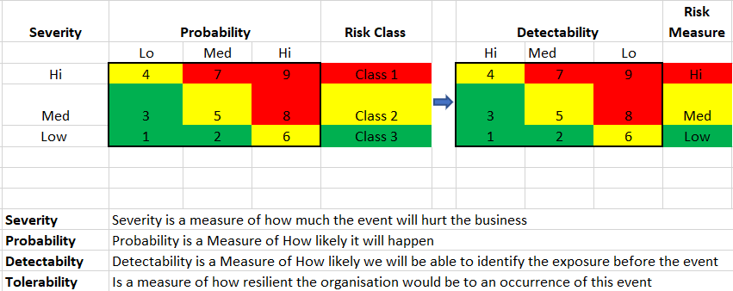
Step 2
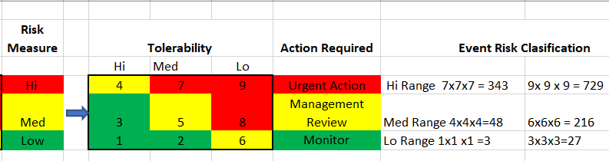

For each of the following items perform a risk assessment and ask the questions which help you determine the level of exposure which currently exists in your organisation by asking for each item the following 6 questions.
- Is this an issue in our organisation?
- If it is not considered an issue how can I demonstrate – where is the evidence?
- How can I measure the effectiveness of the current process?
- How effective is the documentation / training?
- If there are changes in this element how effective would the system accommodate the changes?
Risks to be analysed include the following
1/ Limited or lack of management commitment – Management do not demonstrate support for the activity
2/ Lack of or incomplete description of roles, accountabilities and responsibilities
3/ Limited or lack of resource availability or planning, including staffing in the following areas
- Maintenance Planning
- Reliability
- Engineering
- Technical Records
- Quality Assurance
- Safety Management
- Other
4/ Lack of or ineffective policies
5/ Incorrect or incomplete procedures including instructions
6/ Lack of or Poor Management, Culture and or Manpower relationships
7/ Lack of or Ineffective Organizational Structure
8/ Poor organizational safety culture
9/ Lack of or ineffective safety management processes (including risk management, safety assurance, auditing, training and resource allocation)
10/ Lack or ineffective audit procedures
11/ Incorrect or incomplete or lack of training and knowledge transfer. (Note: Training should reflect the needs of the organization. (Accidents have shown that inadequate training is a hazard and may even lead to accidents.) Unofficial organizational structures Note: These structures may be of a benefit but also may lead to a hazard.
12/ organizational financial distress Mergers or acquisition, Changes, upgrades or new tools, equipment, processes or facilities
13/ Incorrect or ineffective shift/crew member change over procedures
14/ Informal processes (Standard Operating Procedures)
15/ Lack of or poor or inappropriate materials/equipment acquisition decisions
16/ management of Staff Competencies Note: Staff should be hired or assigned according to organizational needs but also according to their skills, qualifications and abilities. An employee with the wrong skill set can be a hazard. This includes management.
17/ Incorrect, poor or lack of internal and external communication including language barriers
18/ Lack of, incorrect or incomplete manuals, or operating procedures (including maintenance)
19/ Lack of, incorrect or incomplete employee duty descriptions
20/ Lack of, incorrect, incomplete or complicated document update processes
21/ Lack of, incorrect or incomplete reports and records
22/ Medical Emergency including any of the following -
Heart attack, Stroke, Kidney stone, Seizure, Nausea, Diarrhea, Carbon monoxide, Medication, Fatigue, Influenza, Upper Respiratory Tract Infection (TI), Urinary Infection TI, Colour vision, Visual field limitations, Mobility limitations, Colostomy bag, Hearing loss,
23/ Fatigue (lack of sleep), Alcohol and substance abuse, Medications, Complacency
24/ Financial, Birth of child, Divorce, Bereavement, Challenging timelines, Inadequate resources
25/ Solvents, Chemical/Biological exposures, Noise, Vibrations, Distractions
26/ Human factors related to design, manufacturing, maintenance and operations.
27/ Over saturation of digital information
28/ Lack of or poor airworthiness verification
29/ Lack of or poor verification of equipment and instruments necessary to a particular flight or operation
30/ Lack of or poor maintenance release
31/ Improper weight and balance calculations
32/ Use of obsolete documents
33/ Lack of, or poor communication (ATC, ramp, maintenance, flight Ops, cabin, dispatch, etc)
34/ Language barriers (Multiple languages)
35/ Poor HVAC (heating, ventilation, and air conditioning)
36/ Noisy work environment
37/ Lack of, or poor Lighting
38/ Poor facilities (inadequate space, equipment or infrastructure)
39/ Lack of, or poor maintenance programs (Including imprecise maintenance data or transcription errors when creating job-cards)
40/ SUPS (Suspected Unapproved Parts)
41/ Maintenance movement of aircraft/run-ups
42/ Poor control of outsourced maintenance (any maintenance completed outside the maintenance facility or organization including third party maintenance)
43/ Lack of or, inappropriate specialized processes (including NDT, plating, welding, composite repairs etc…)
44/ Lack of or, improper Airworthiness Directive Control
45/ Lack of or, inadequate reliability program
46/ Lack of, or poor tool accountability (Including traceability or registration)
47/ Lack of or unsafe or unreliable equipment, tools, and safety equipment.
48/ Mis-calibrated tools
49/ Lack of, or inadequate instructions for equipment, tools, and safety equipment
50 / Aircraft configuration variability (Similar parts on different models)
Sofema Online currently offer 15 online training courses to support the development of your EASA Part CAMO Organisation – for details please see www.sofemaonline.com or email online@sassofia.com

