Case Study – Aircraft Fire in the Hangar During Maintenance
Consider the following event and create a Barrier List as to why this even could not happen in your facility related to the following:
- Emergency Response Preparedness
- Manpower Competence
- General House Keeping Procedures
- Fire Response Availability - Fire First Responder Training
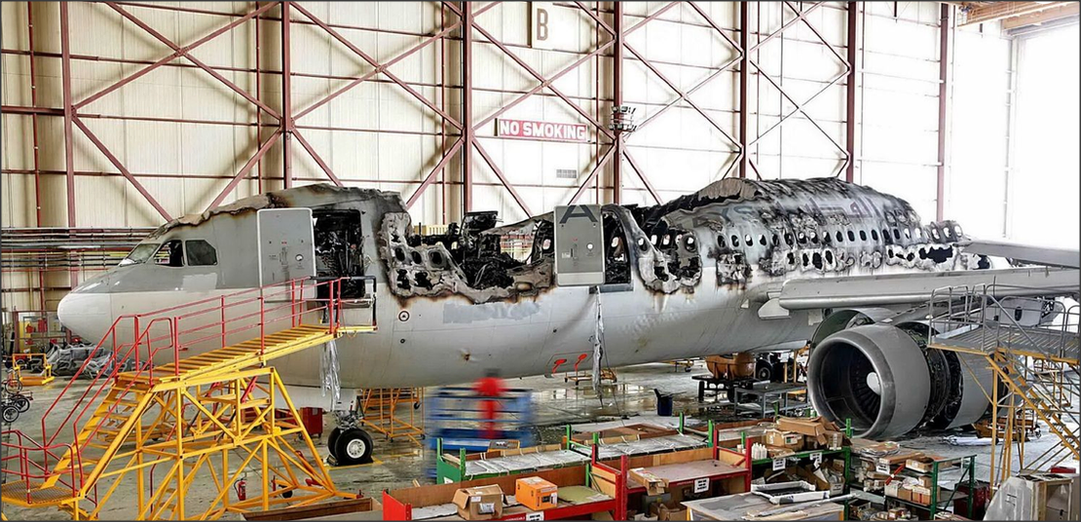
Attribution Photo Flight Global
An Airbus A300B4-622 aircraft had been flown to xxxxx for a C Check maintenance input with an MRO,
During this maintenance input, a fire broke out in the cabin.
Firefighters extinguished the fire but got not prevent the cockpit and the cabin area of the aircraft to be (nearly) completely destroyed.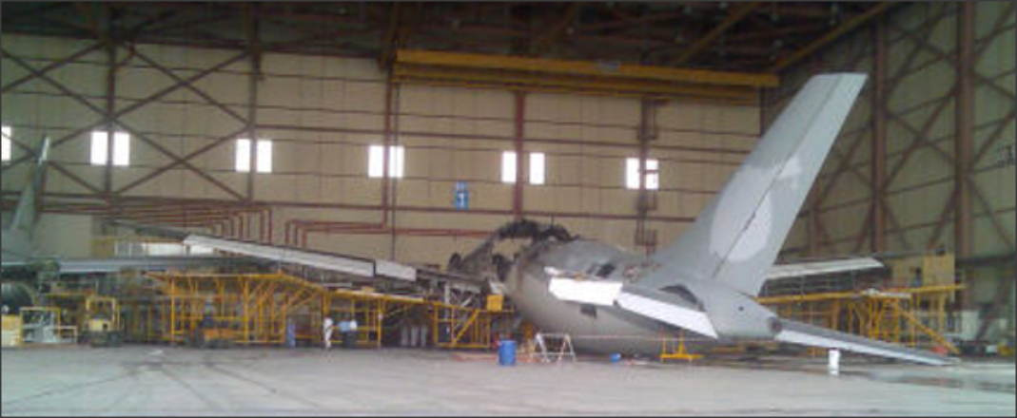
Attribution Photo Flight Global
The probable cause for the fire was either one or a combination of the following factors:
- Electrical Spark
- Faulty lighting causing a spark
- Electrostatic discharge from paint spraying equipment
Several contributory factors have been identified they were:
- The interior of the aircraft was being painted; this could have caused flammable vapors to collect (in certain areas).
- The fire could spread easily as there were only a limited amount of fire extinguishers available.
- There were (used) paint cans, rags, plastic (polythene) sheets and chemicals inside the fuselage which probably exacerbated the fire.
- Company standards and company procedures were possibly not followed by staff working in or on the aircraft.

